**Question :**

**● Create an FTP server**

**● Access FTP server from windows command prompt**

**● Do an MITM and username and password of FTP transaction using wireshark and dsniff.**

**ANS:**

1. Installed FTP Server on victim Machine

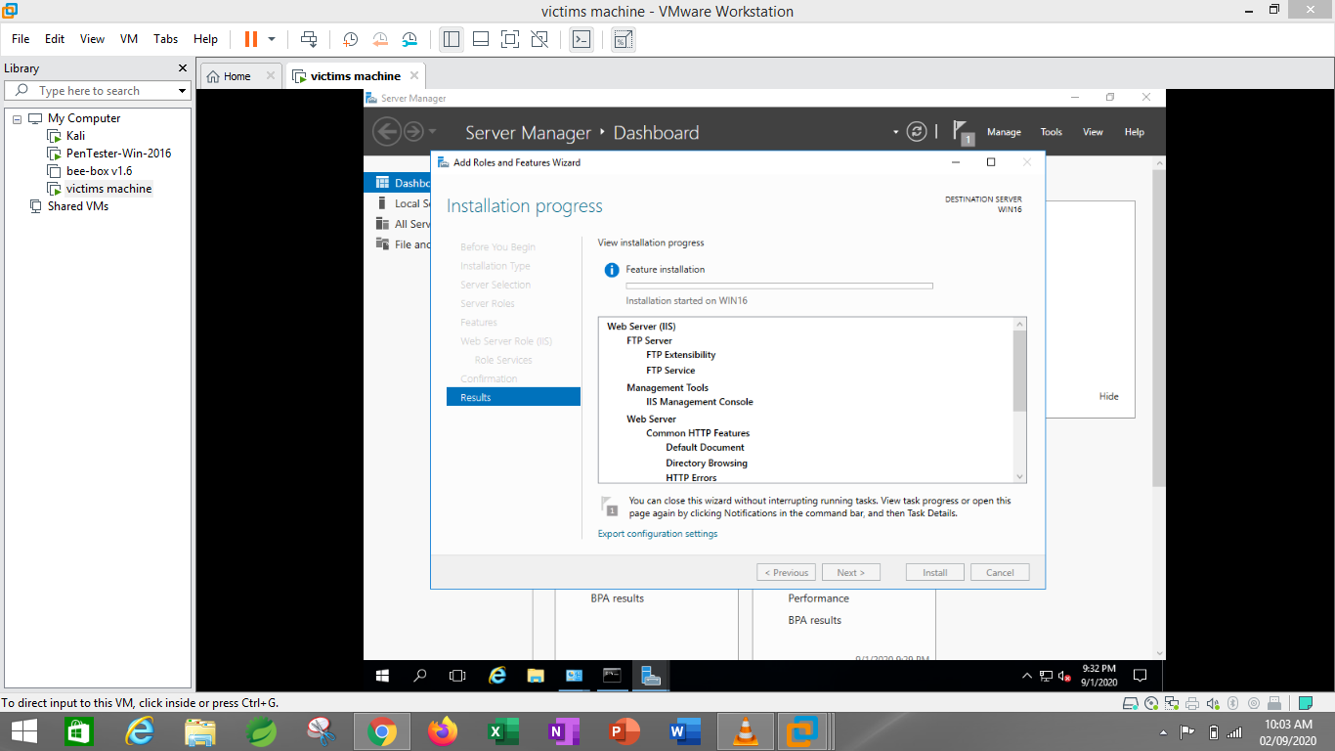

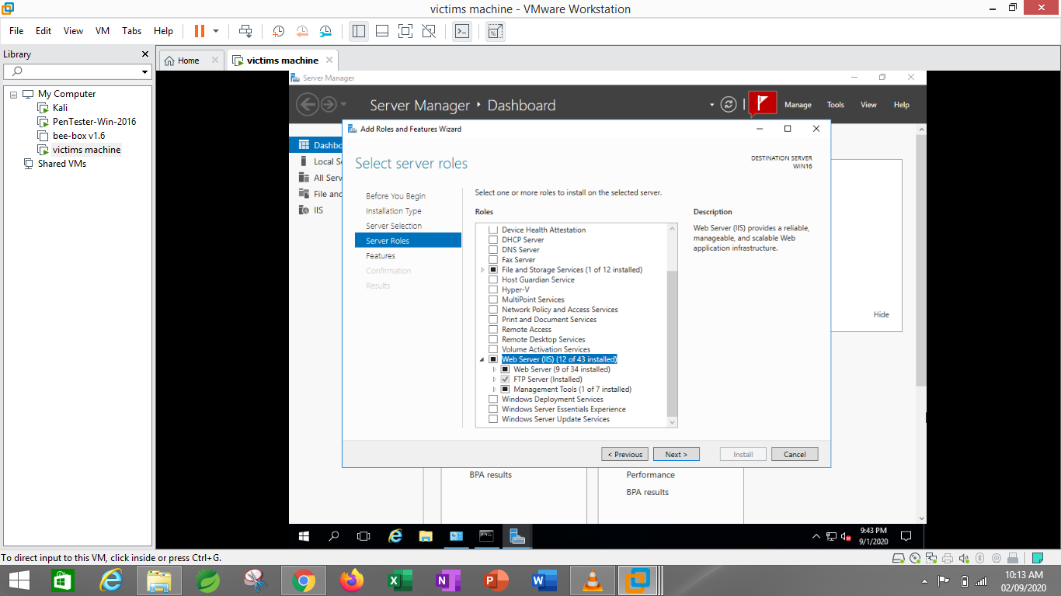

1. Added site to FTP

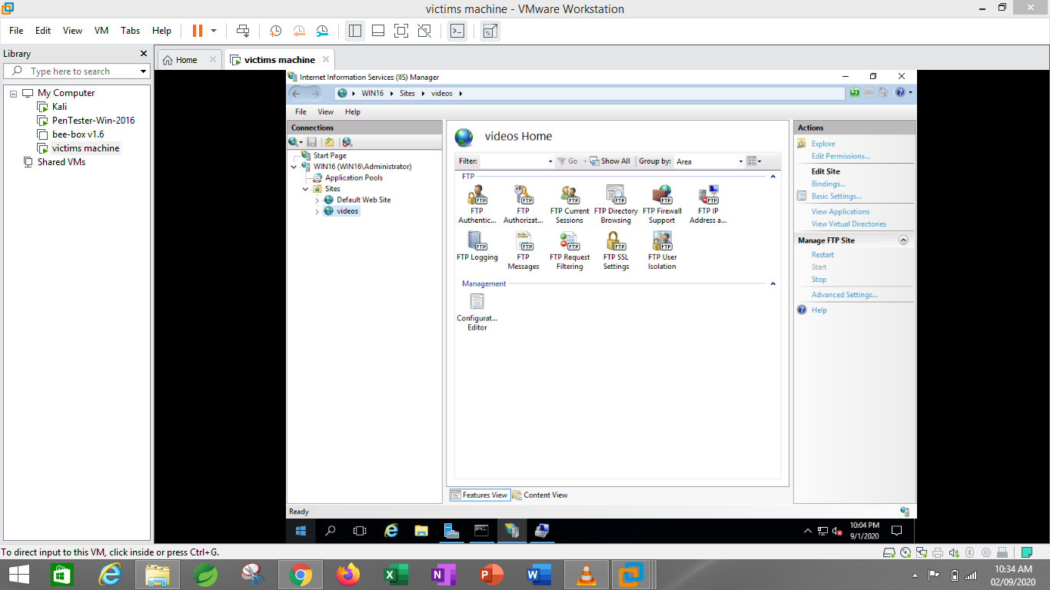

1. Checked that FTP is working

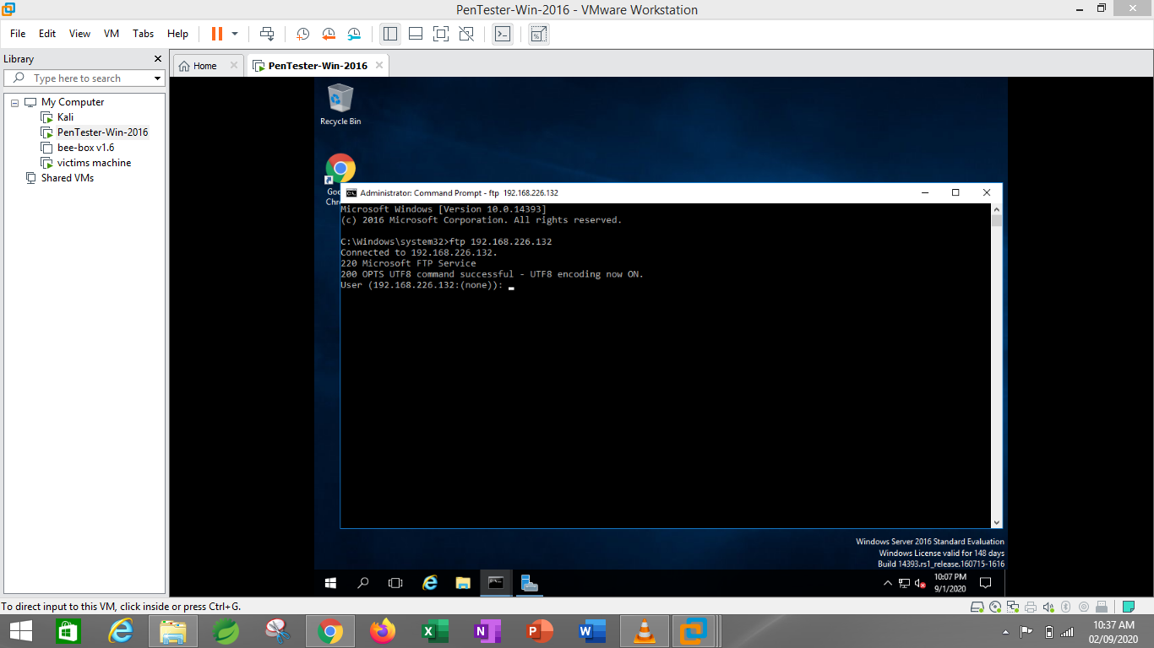

1. Perform port scanning in NMAP

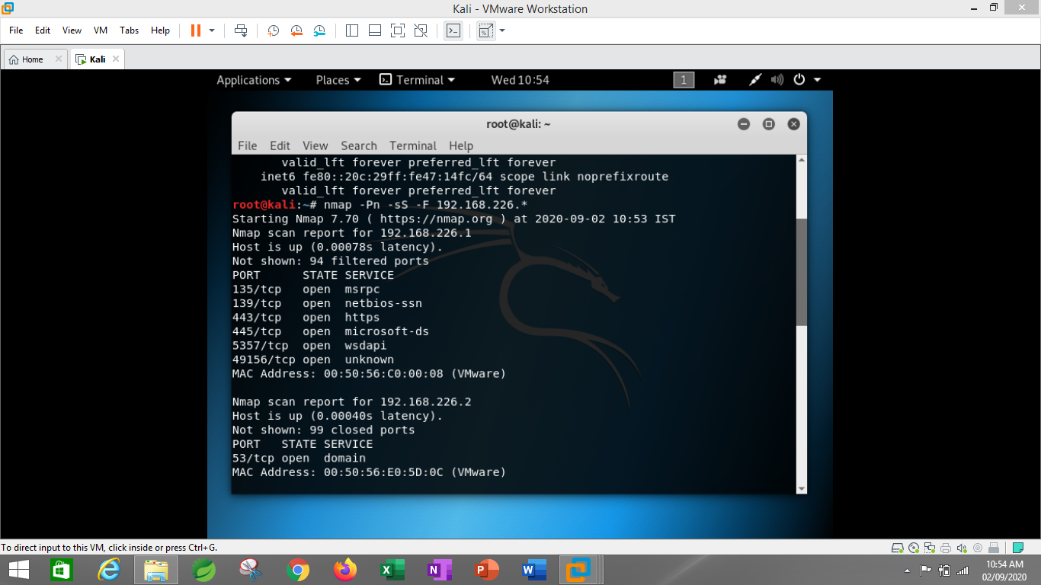

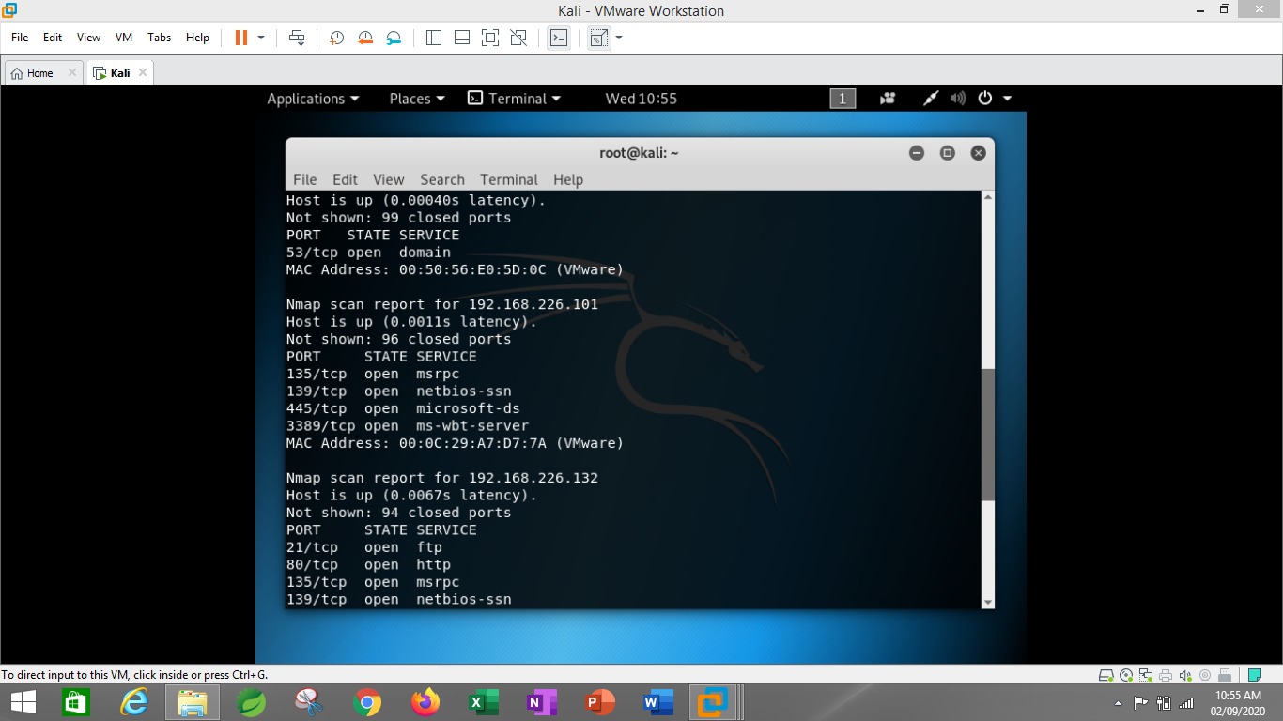

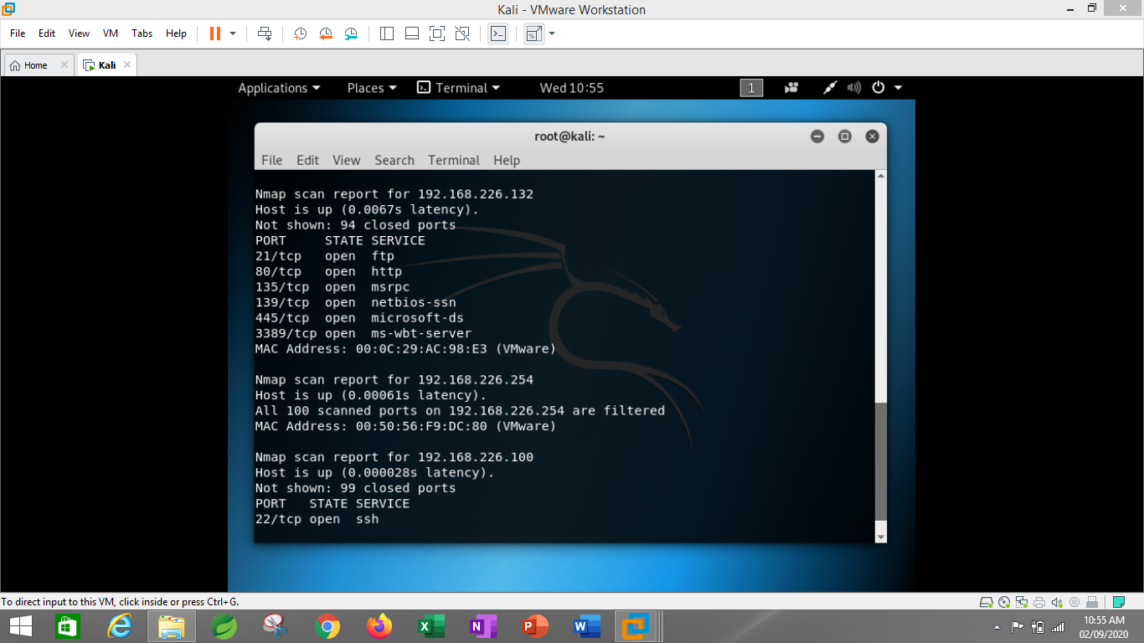

1. Installed dsniff and activated arp spoofing and dsniff

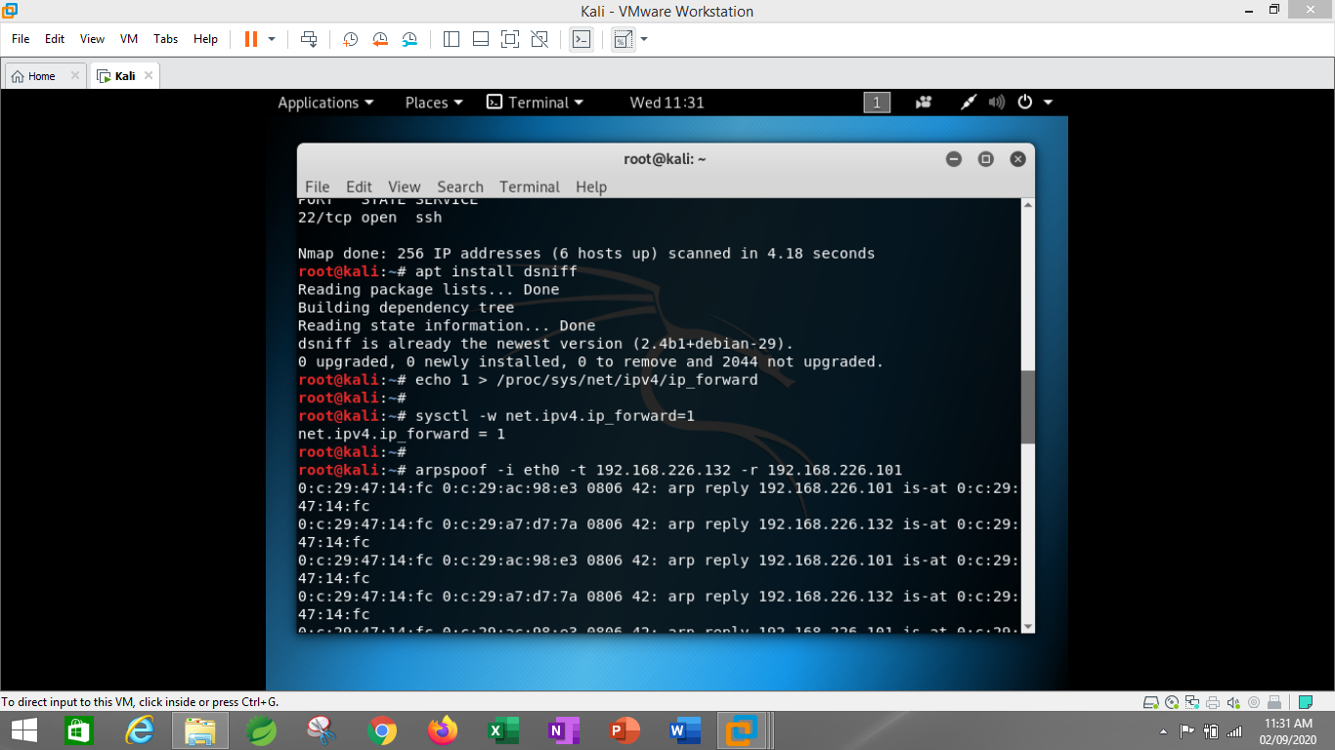

1. Username and password captured in Wireshark

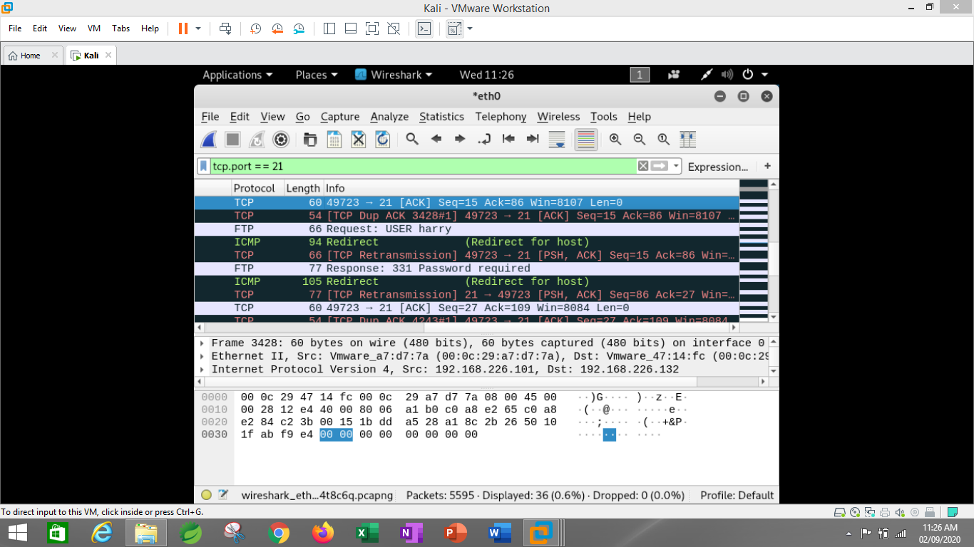

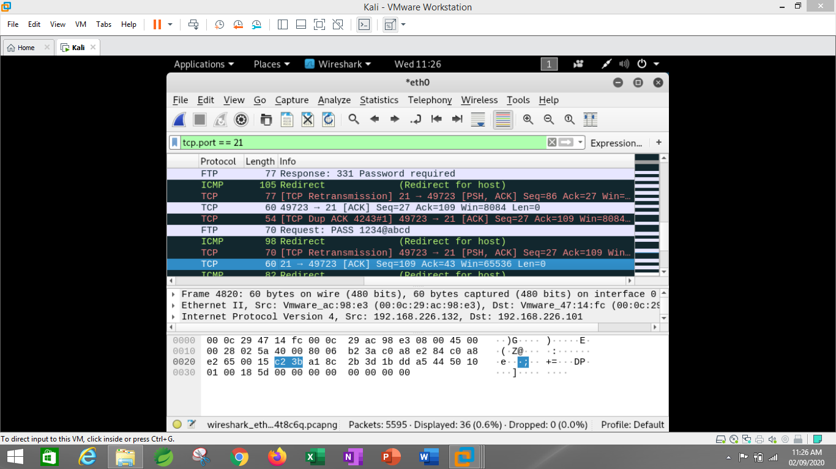

1. Username and Password captured in dsniff

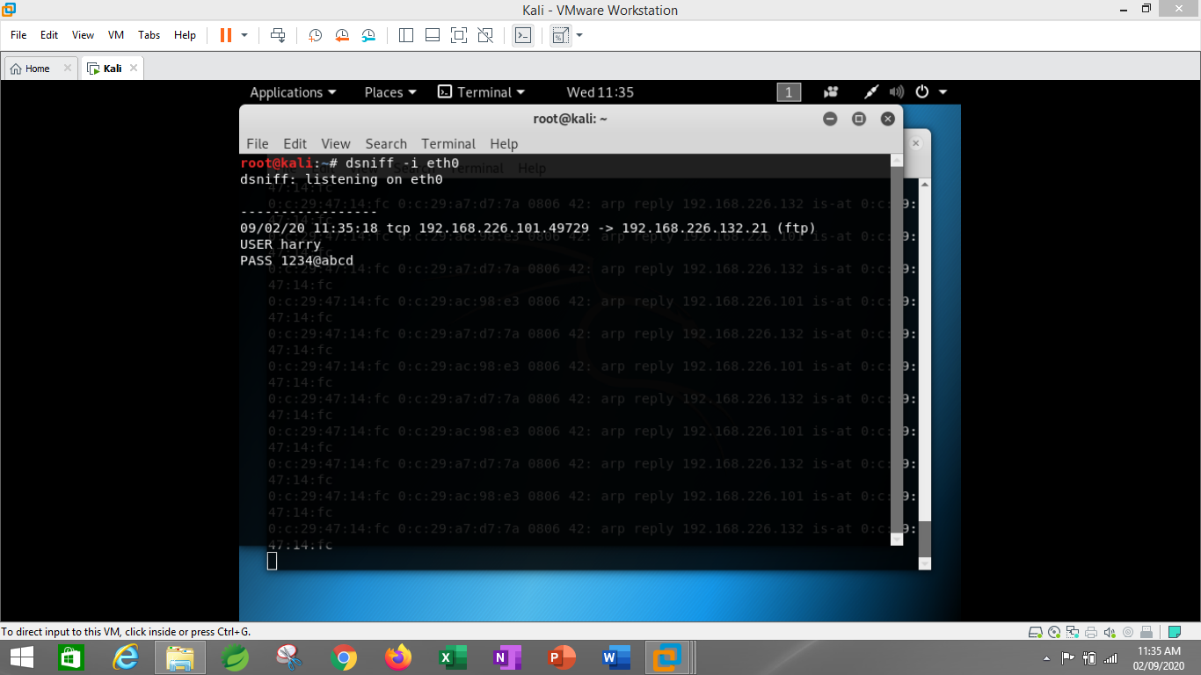

**Question 1:**

**● Create payload for windows .**

**● Transfer the payload to the victim's machine.**

**● Exploit the victim's machine.**

**ANS:**

1. Created Exploit for windows. (Following are some screenshots of process)

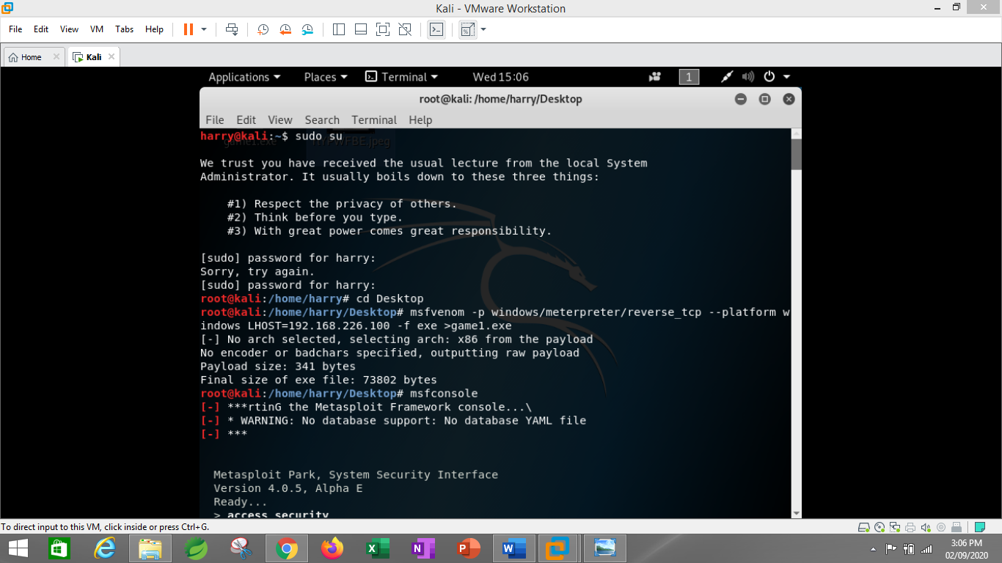

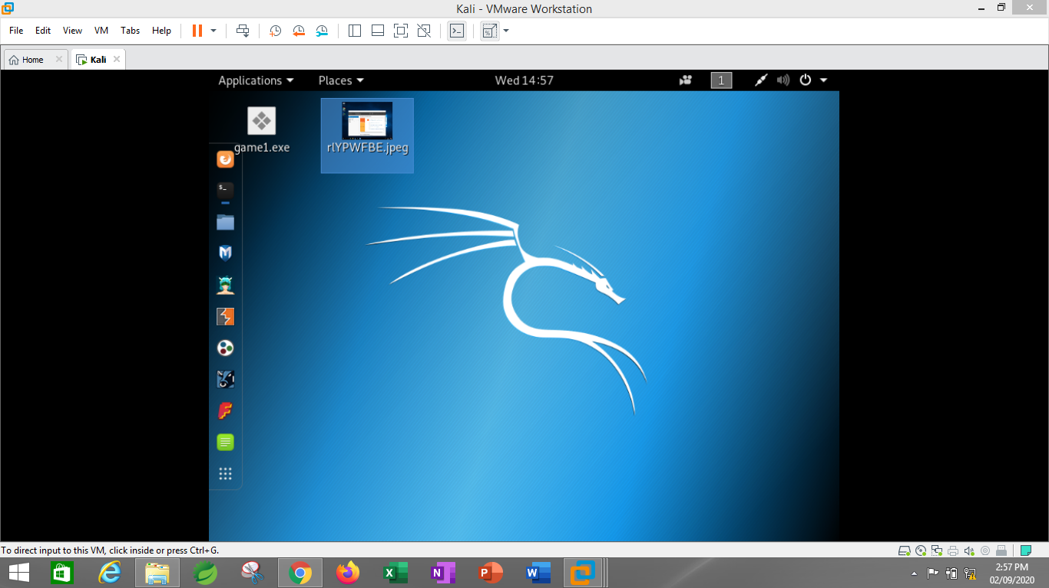

1. Transferred payload to victim

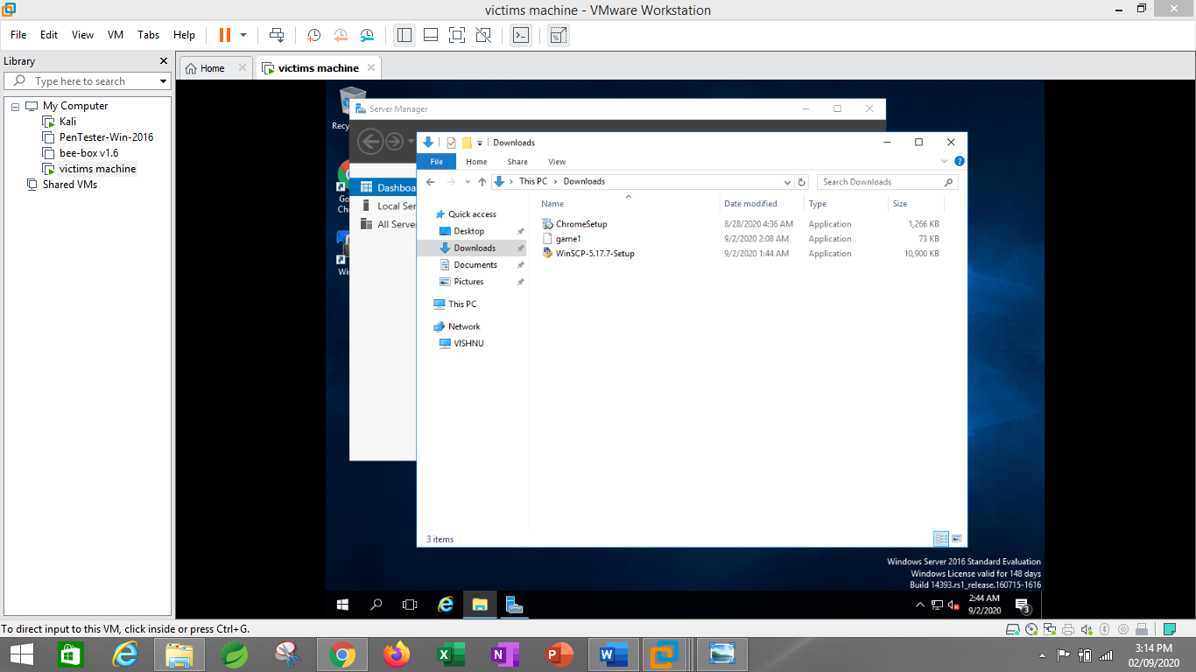

1. Exploited victim.



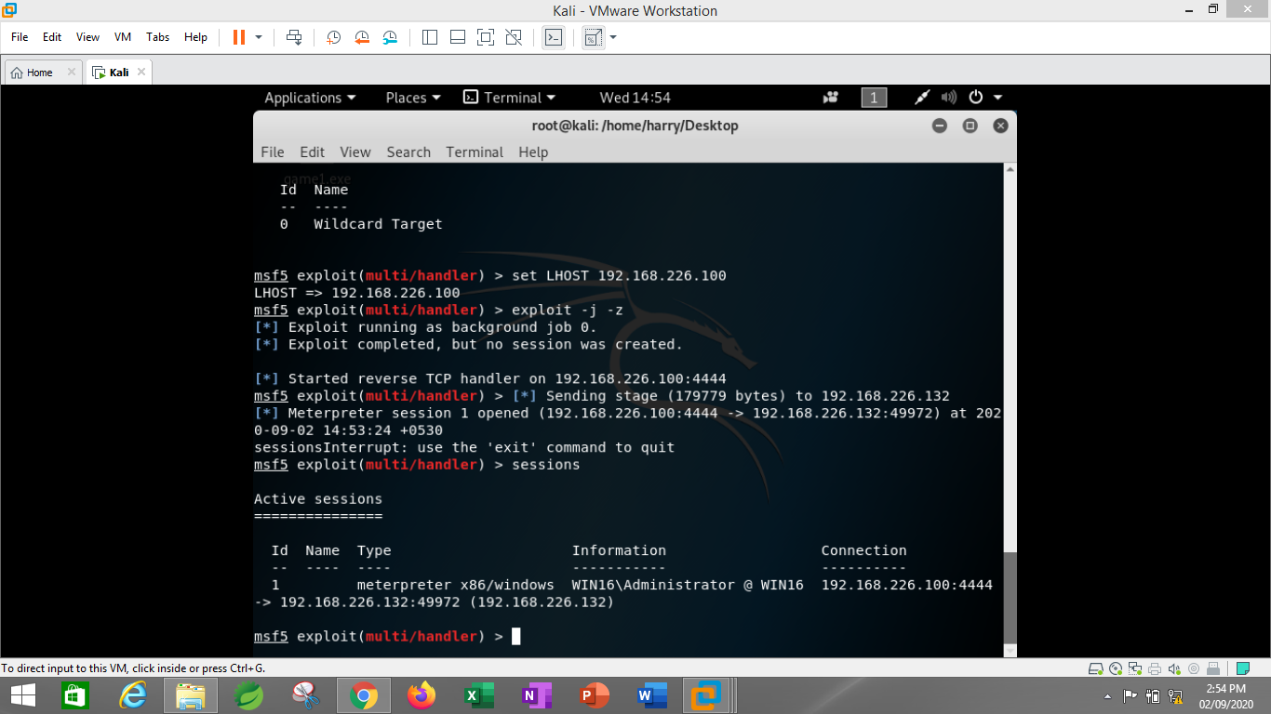

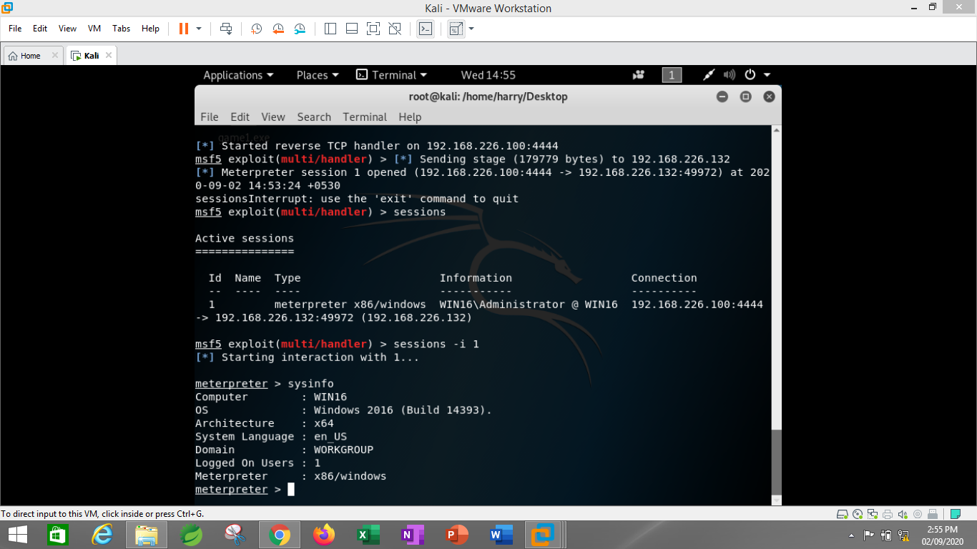

1. Taken Screenshot of victim.

